Chronic Rpi quick start guide

# Hardware set-up

* Connect the camera on the Rpi
* Connect the dsPIC Hat on the Rpi
* Connect the Rpi to the PC with an ethernet cable
* Power up the Rpi

# PC configuration

## Ethernet configuration

* In the **start menu**, choose **Settings/Network & Internet**
* Choose **Change adapter options**
* Double-click on your ethernet connexion
* Select **TCP/IPv4** and click on **Properties**
* Use these parameters:

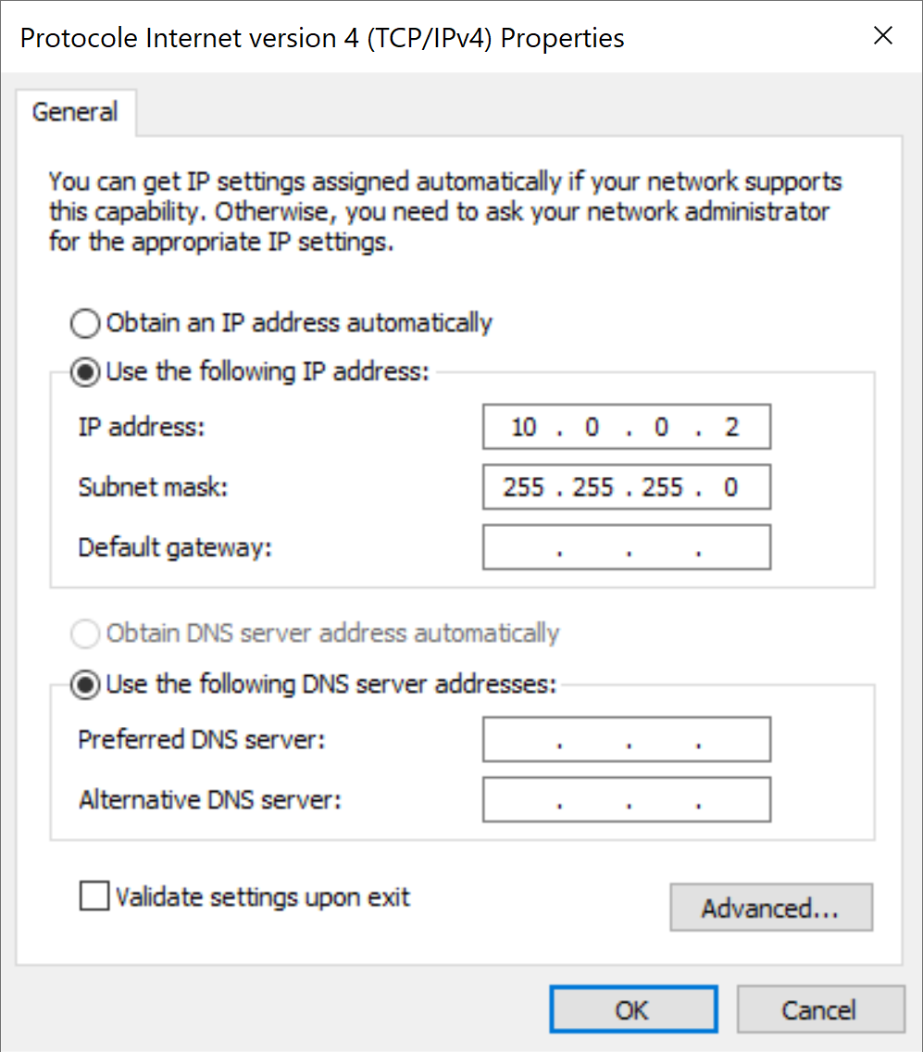

## User's creation

Create a new user named **pi**, with raspberry as password.

## Data folder setup

* On the PC hard drive, create the folder **C:\raspberry3\data**
* In the **Properties** of **C:\raspberry3**
  + Select the **Sharing** tab
  + Click on **Share** and verify that pi is allowed to read/write in the folder:

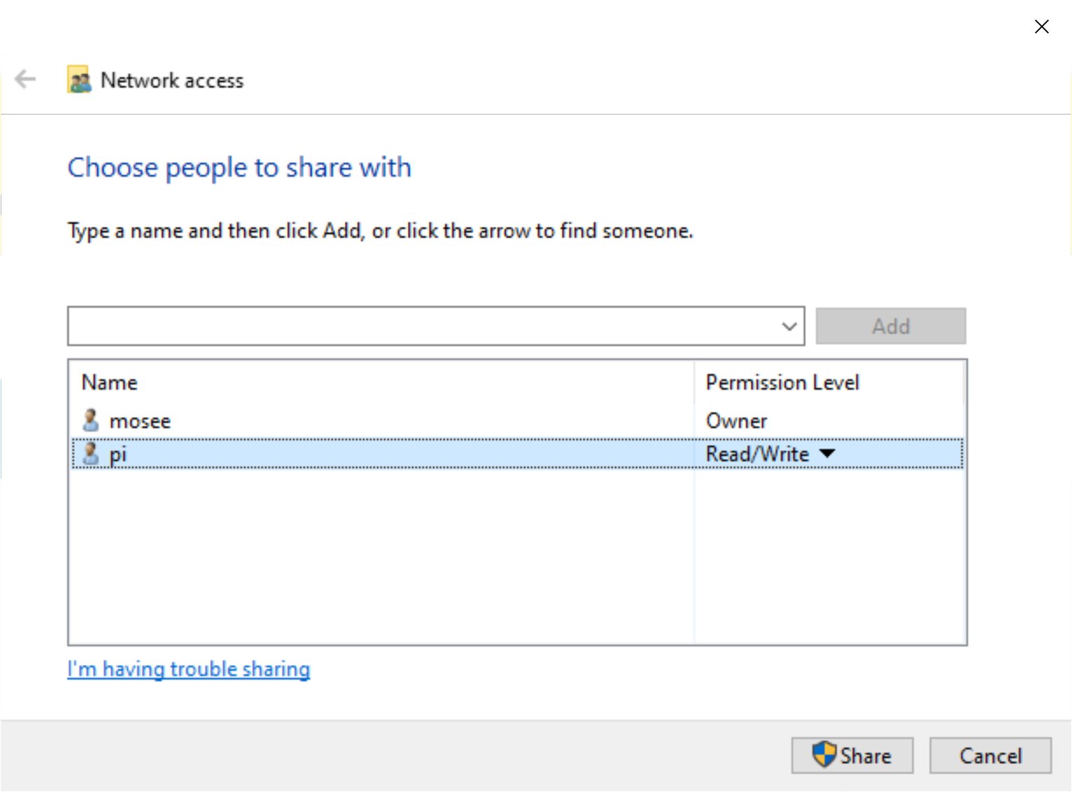

* + Select the **Security** tab
  + Verify that pi has all the permissions except **Full control** and **Special permissions**

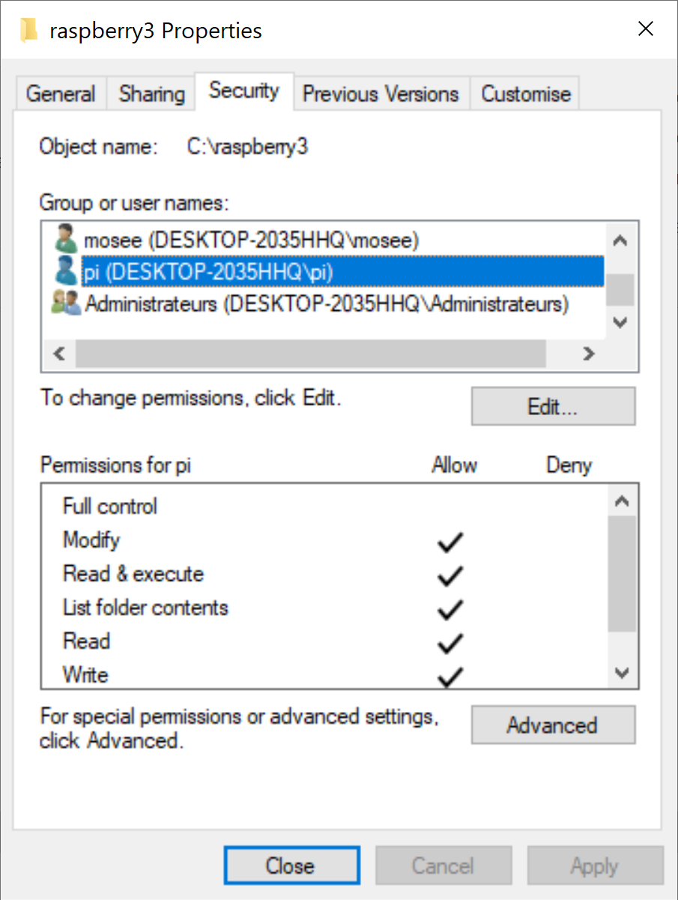

* + In the same tab, click on **edit…**
  + In the new window, click on **Add…**

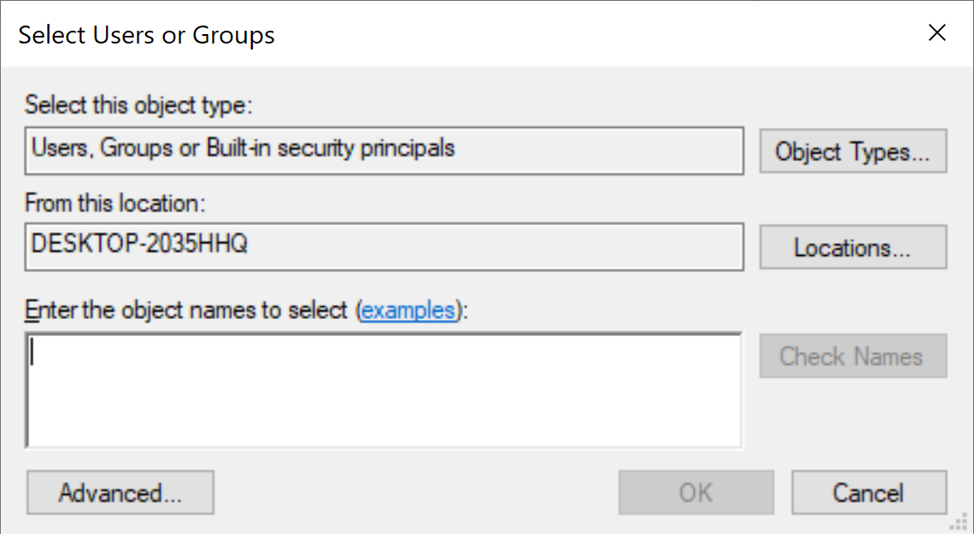

* + In **Enter the object names to select**, type **Authenticated users** or **Utilisateurs authentifiés** for French version of Windows (You can click on **Advanced…** to find a list of the available names).
  + Give them the same permissions as pi.

## Putty

* Download and install **PuTTY**
* Start **PuTTY** and use the following parameters:

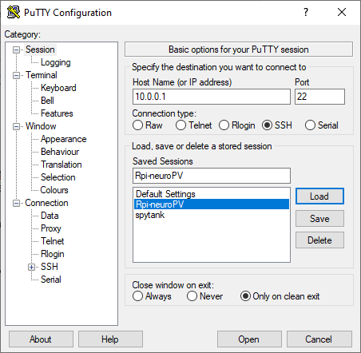

# Launching the acquisition

* Start PuTTY and open the connexion
* If an authentication message appears (only the first time a PC connect to a Rpi), answers **Yes**
* The login is **pi** and the password is **raspberry**
* Go to the application folder using : **cd Documents/EndoNeuro-firmwares/endoneuro-Rpi**
* The command to launch the acquisition is **sudo sh ./scripts/run.sh**